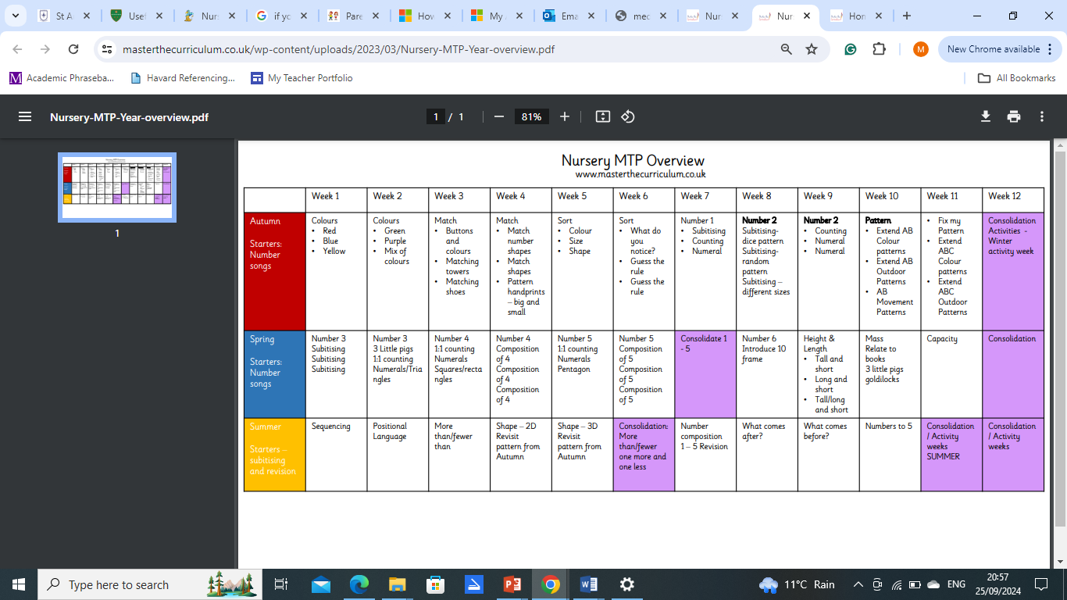**Maths long-term plan for Nursery**