2024-2025 | Autumn 1 | Autumn 2 | Spring 1 | Spring 2 | Summer 1 | Summer 2
Theme | Incredible me  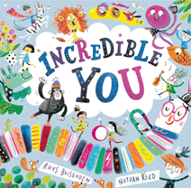 | Let’s celebrate  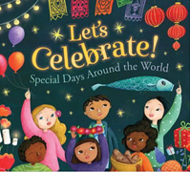 | Ticket to Ride  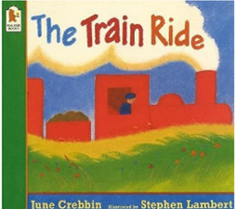 | Growing  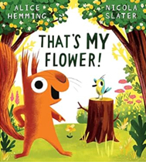 | Amazing animals  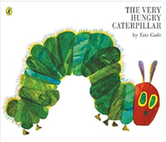 | Fun at the seaside  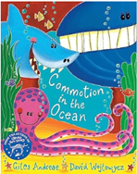
Communication and language  Children engage in stories, songs, rhymes, poems and non-fiction texts. | Baseline  We’re going on a bear hunt  Kipper  Fox’s sock  Hug | Brown bear, brown bear what do you see?  Each, peach, pair. Plum  Where’s spot?  The Christmas story | The train ride  Hug  Wheels on the bus  Naughty bus | Jaspers beanstalk  Peepo  Titch | The Very Hungry Caterpillar  Come on Daisy | Rainbow Fish  Dinosaurs roar  Elmer  Dear Zoo
Literacy | Sound discrimination – environmental | Sound discrimination – instrumental | Sound discrimination – body percussion | Rhythm and rhyme | Voice sounds | Oral segmenting and blending

Specific Areas | School Readiness End of Year Goals
Literacy | - I can spot and suggest rhymes.  - I can count or clap syllables in a word.  - I can recognise words with the same initial sound, such as money and mother.  - I can engage in extended conversations about stories, learning new vocabulary.  - I can use print and letter knowledge in my early writing e.g. writing a pretend shopping list that starts at the top of the page.
Communication and language | - I understand questions or instructions that have two parts, such as “Get your coat and wait at the door.”  - I am able to talk about rhymes and books and tell a story.  - I use longer sentences of 4 -6 words.  - I use talk to organise my play and myself: “Let’s go on a bus, you sit there, I will be the driver.”  - I can listen attentively and respond to what I hear.

